Ashcon Abae

CMSC 405 7981 Computer Graphics

3 November 2019

Project 1 Documentation

In this document, you can find screenshots of all 3 images undergoing the transformations defined in the project description. To reiterate, each image will undergo – in sequence – the transformations found below:

1. Translate -5 in the x direction and +7 in the y direction
2. Rotate 45 degrees counter clockwise
3. Rotate 90 degrees clockwise
4. Scale 2 times in the x direction and 0.5 times in the y direction

To clarify, the 3 images I created are representations of the numbers 2, 5, and 7. From my test plan discussed at each iteration of the animation below, I have come up with the results that the submitted code satisfies all requirements as described in the Project 1 Assignment Description:

1. 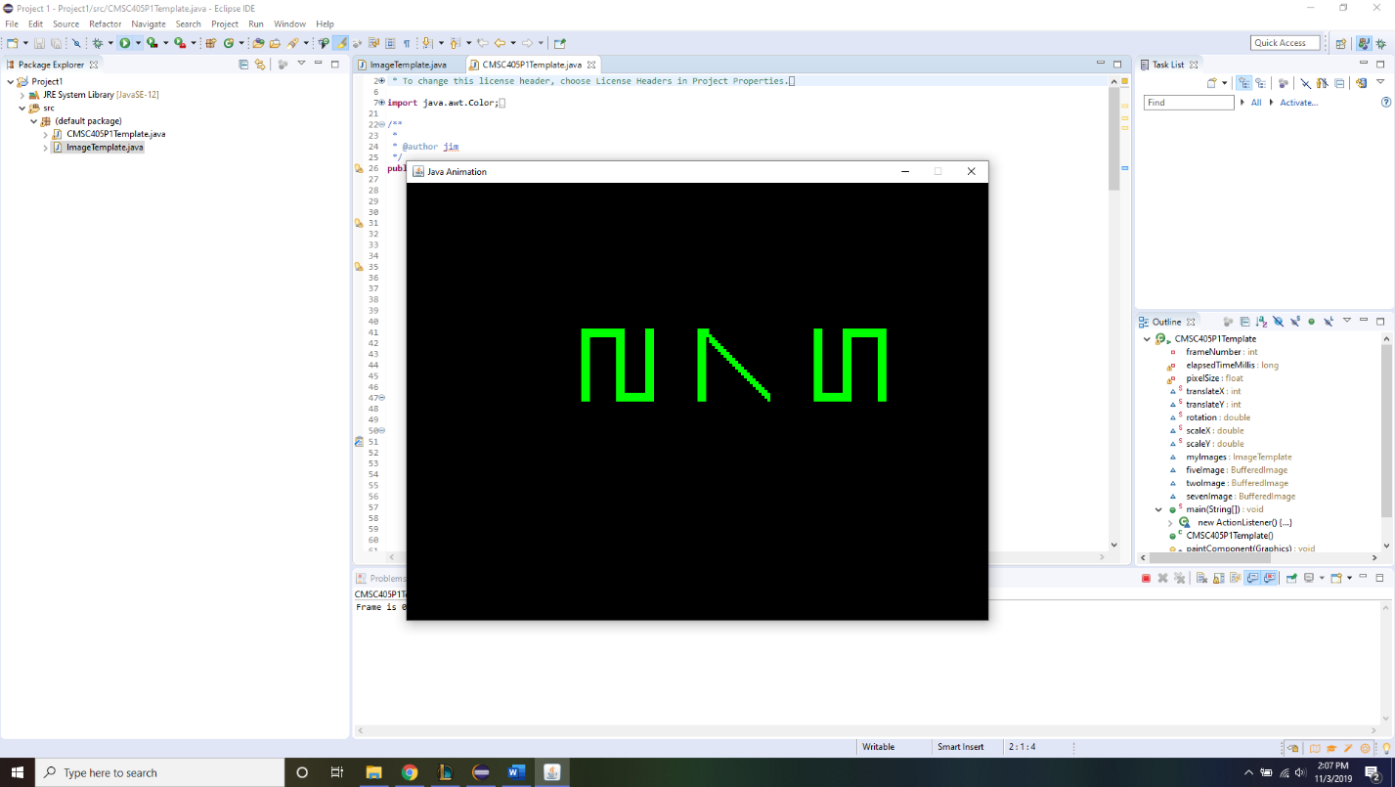In this first screenshot, this is frame 1 of our animation. This frame simply displays the images as is without any translations, rotations, or scaling. That is, our image is at (0,0) translation, not rotated at all, and scaling is 1.0 in the x and y directions. To test if this is correct, we can see that each image is 25x25 pixels and there is 40 pixels of space in between the start of each drawing of the images. I tested this by counting the number of pixels in each image I originally came up with and counting the pixels of space I left in between the start of my drawing of these images on the canvas.
2. 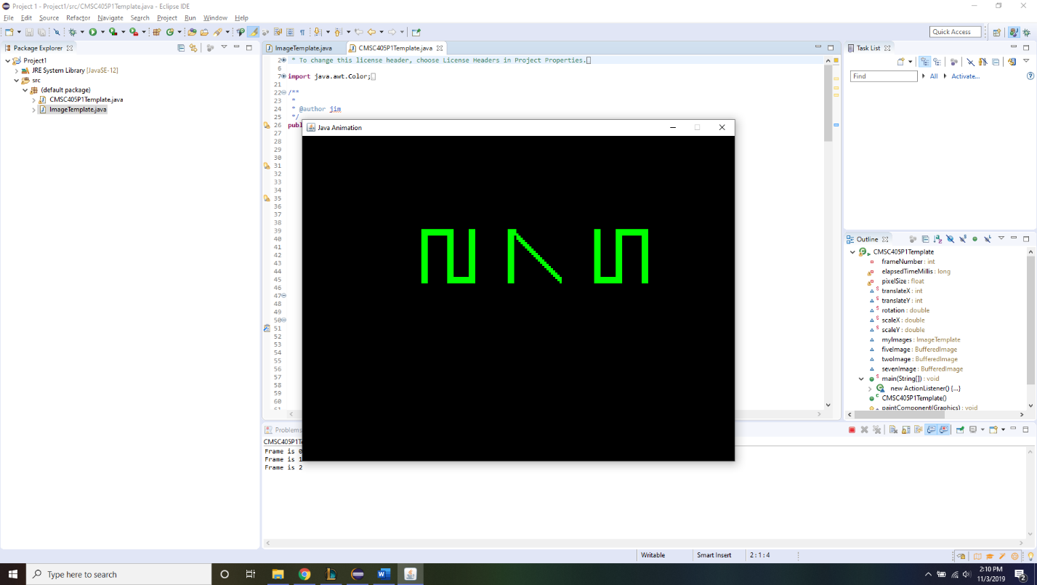In this next screenshot, this is frame 2 of our animation. This frame translates our original image -5 in the x direction and +7 in the y direction. That is, our image is at (-5,7) translation, not rotated at all, and scaling is 1.0 in the x and y directions. To test if this is correct, we still have our original 25x25 pixel images that are separated by 40 pixels at the start of each drawing of the images. When looking at the translations in this iteration of our animation however, we can further see that our original translation is offset by -5 in the x direction and 7 in the y direction for all 3 images. I tested this by counting the number of pixels in each image I originally came up with and counting the pixels of space I left in between the start of my drawing of these images on the canvas, then comparing our original translation to the translation of this iteration we can see it has shifted in the required amount.
3. 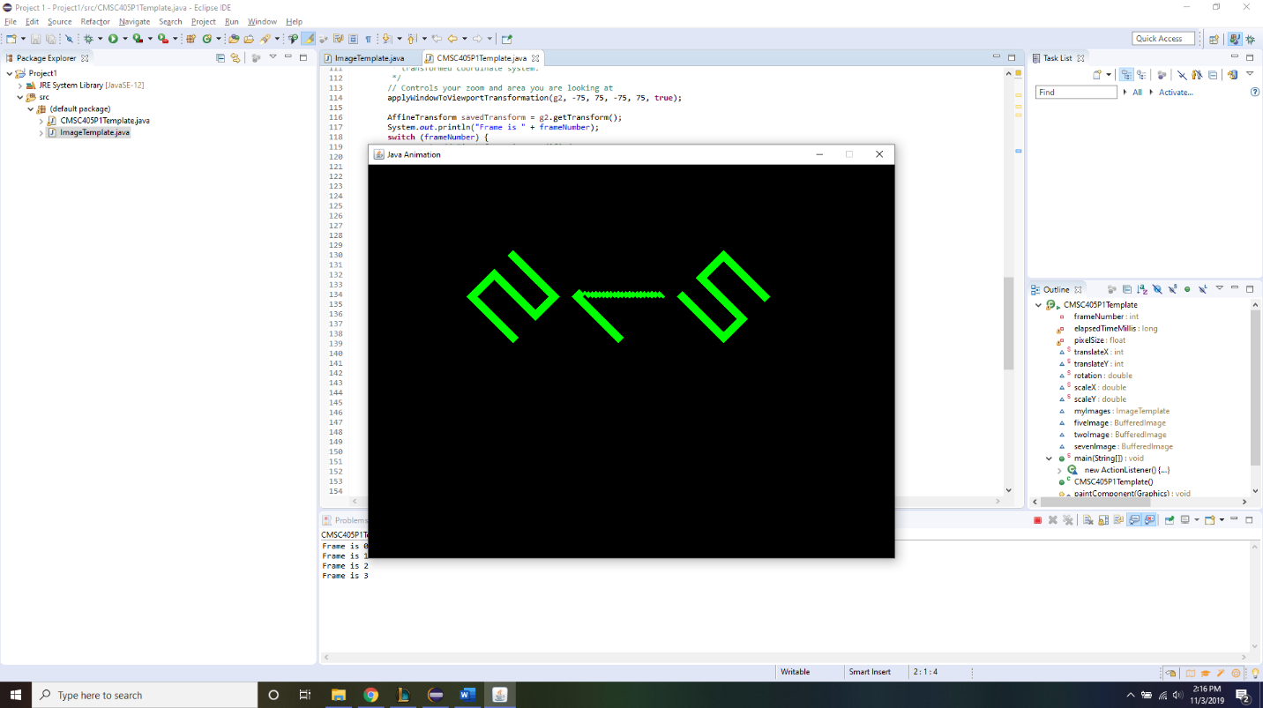In this next screenshot, this is frame 3 of our animation. This frame still has (-5,7) translation and it also rotates our image 45 degrees counter clockwise. To test if this is correct, we still have our original 25x25 pixel images that are separated by 40 pixels at the start of each drawing of the images and have a translation offset of -5 in the x direction and 7 in the y direction. Furthermore, these images are now rotated by 45 degrees counter clockwise. I tested this by counting the number of pixels in each image I originally came up with and counting the pixels of space I left in between the start of my drawing of these images on the canvas, then comparing our original translation to the translation of this iteration we can see it has shifted in the required amount, and has a rotation of 45 degrees counter clockwise (positive) when compared to original rotation.
4. 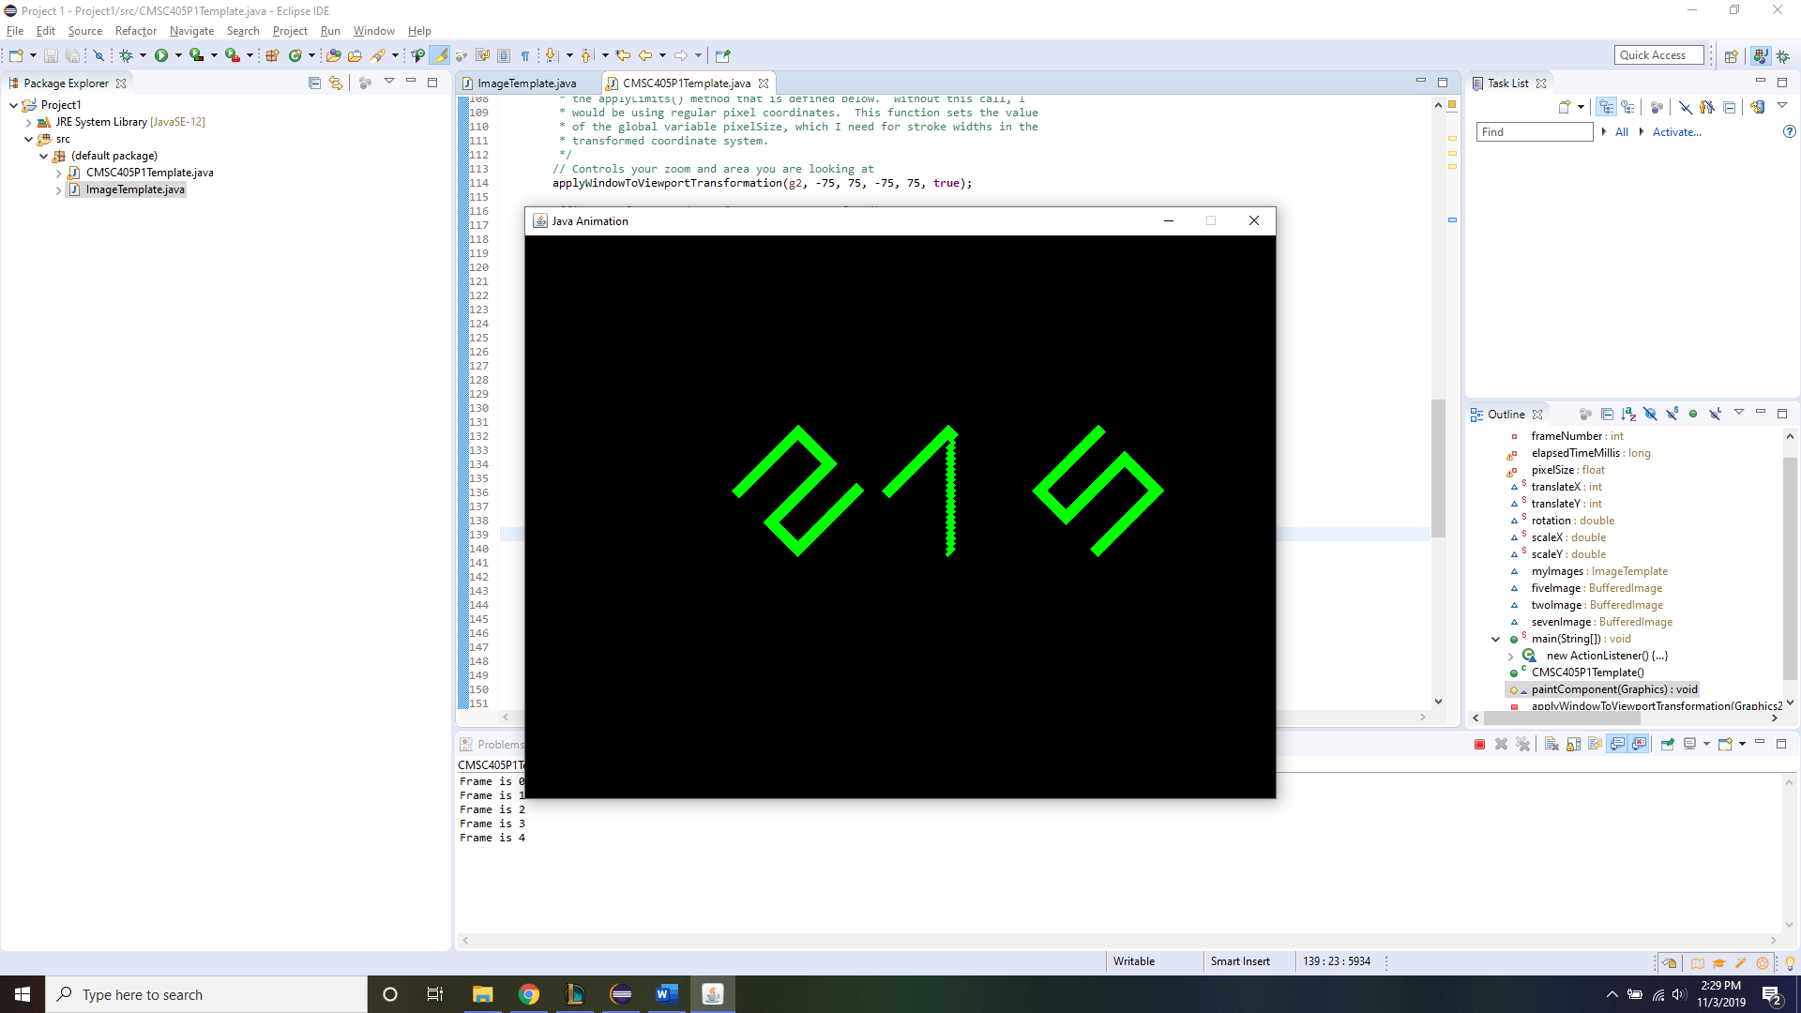In this next screenshot, this is frame 4 of our animation. This frame still has (-5,7) translation, but 90 degrees in the clockwise direction has been added to our rotation. This means that our rotation when compared to the original image is 45 degrees in the clockwise direction. To test if this is correct, we still have our original 25x25 pixel images that are separated by 40 pixels at the start of each drawing of the images, have a translation offset of -5 in the x direction and 7 in the y direction, and have been rotated 45 degrees counter clockwise. This iteration, however, adds 90 degrees clockwise to our rotation, making our overall rotation when compared to the original rotation 45 degrees clockwise. I tested this by counting the number of pixels in each image I originally came up with and counting the pixels of space I left in between the start of my drawing of these images on the canvas, then comparing our original translation to the translation of this iteration we can see it has shifted in the required amount, and has a rotation of 45 degrees clockwise (negative) when compared to original rotation.
5. 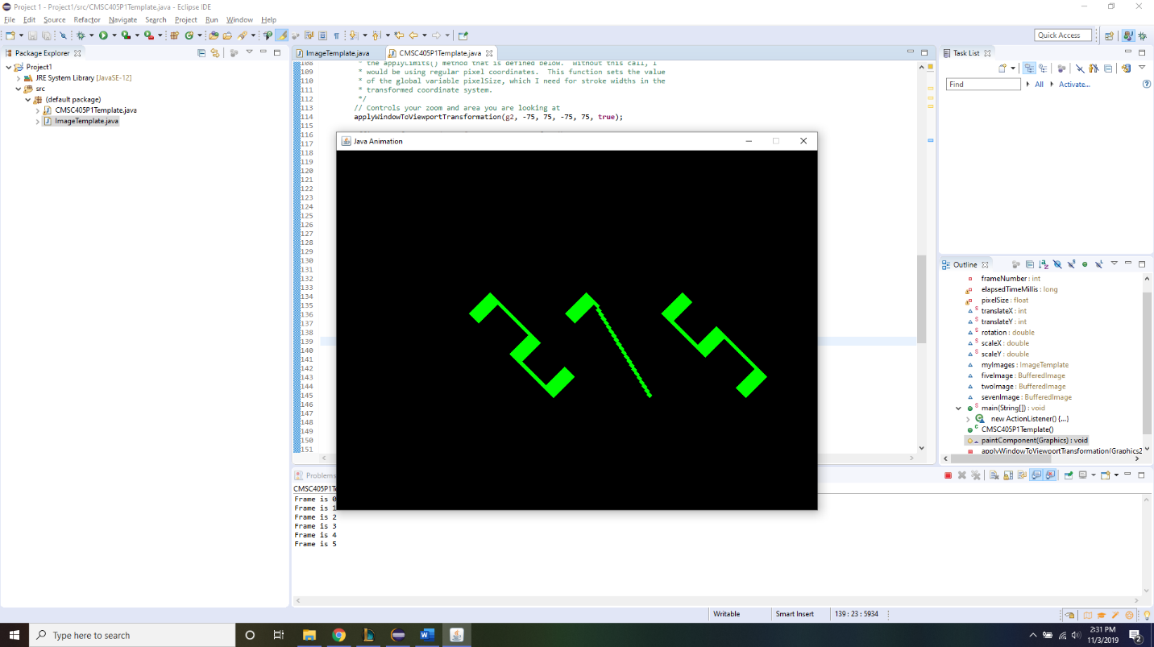In our final screenshot, this is the fifth and final frame of our animation. This frame still has (-5, 7) translation and 45 degree rotation in the clockwise direction. Additionally, this frame scales our image 2 times in the x direction and 0.5 times in the y direction. To test if this is correct, we still have our original 25x25 pixel images that are separated by 40 pixels at the start of each drawing of the images, have a translation offset of -5 in the x direction and 7 in the y direction, and have been rotated 45 degrees clockwise (when compared to original images). This iteration additionally scales our x pixels by a multiple of 2 and our y pixels by a multiple of 0.5. I tested this by counting the number of pixels in each image I originally came up with and counting the pixels of space I left in between the start of my drawing of these images on the canvas, then comparing our original translation to the translation of this iteration we can see it has shifted in the required amount, and has a rotation of 45 degrees clockwise (negative) when compared to original rotation, and finally counting the number of pixels each of these images has and ensuring the correct scaling when compared to original 25x25 pixel images is the required amount.